

Real-Time Testing and Simulation Software

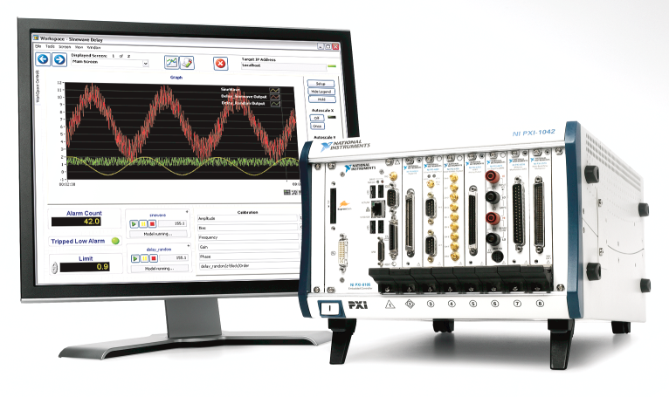

2014 Tutorial

**NI VeriStand Tutorial Exercise**

During this hands-on exercise you will learn how NI VeriStand can be used to create real-time testing applications. This version of the exercise provides a software-only version of the exercise to allow it to be completed without any additional hardware.

In this exercise you will be building a model-in-the-loop (MIL) test system to test a helicopter control system. The system consists of an electronic control unit (ECU) that includes embedded software which uses the position set-point and position feedback (elevation, travel, motor pitch) from the helicopter to calculate the appropriate motor commands to provide the desired controllability and stability for the helicopter system.

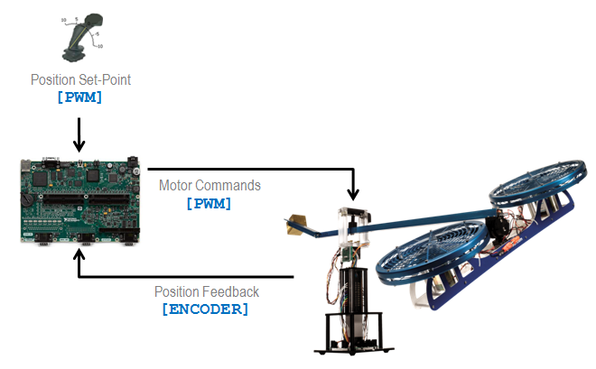

Model-in-the-loop (MIL) testing is primarily performed when the control algorithm is still being designed. It uses software models of the system that accurate represent the system behavior to perform virtual tests in a pure simulation environment. To implement the MIL test system, you will connect the control software to the helicopter software model in NI VeriStand to evaluate the expected system behavior. At the end of this exercise, there are instructions for how you can replace the simulated control software with the actual ECU hardware and use physical I/O interfaces to connect it to a real-time simulation of the helicopter software model to produce a hardware-in-the-loop (HIL) test system.

***Please keep in mind*** - most of the techniques that you use to create this example will be relevant to any real-time testing application (creating user-interface, calculated channels, hardware interfaces …). Therefore, even If you do not create MIL or HIL test systems, this exercise will still provide you with a hands-on introduction to NI VeriStand.

**Background**

**Unit Under Test**

In this exercise, you will be testing a helicopter control algorithm. The control algorithm (for MIL testing) or electronic control unit (ECU) with deployed control software (for HIL testing) will therefore be the unit under test (UUT). The control algorithm was created using the LabVIEW Control Design and Simulation Module. The control consists of a cascaded PID flight control algorithm that will achieve a user specified elevation and rotational position. The control algorithm uses 6 inputs and 2 outputs as listed below:

**Inputs**

Elevation Set Point

Travel Set Point

Pitch Encoder Pulses

Elevation Encoder Pulses

Travel Encoder Pulses

Reset

**Outputs**

Left Motor Power

Right Motor Power  
  
Notice that there is no set point for Pitch. This is because the controller will always attempt to level the pitch once the other two set points have been achieved. The reset input is used to reset the controller’s current values for encoder position.

**System Dynamics Model**

To properly test the control algorithm, we will need a model that accurately simulates the dynamic behavior of the helicopter system by generating the appropriate outputs based on the given inputs and the effects of the environments (wind, gravity, etc). For this example you have been provided a pre built model that was created using the LabVIEW Control Design and Simulation Module. The model has 2 inputs (left and right motor power) as well as 6 outputs (pitch, travel, and elevation position and velocity). The model will produce the appropriate outputs to simulate the response of the system to the control algorithms motor power values.

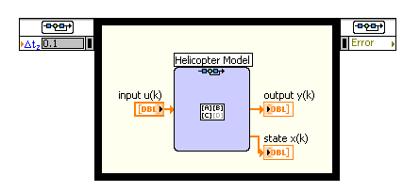

To better visualize the behavior of the system dynamics model, you have also been provided the necessary files to produce a 3D image of the helicopter system as shown below.



This 3D image will be connected to the outputs of the system dynamics model to animate it appropriately.

**Step-by-Step Instructions**

**NOTE:** “<Public Documents>” refers to a specific windows directory on your computer. This folder contains NI VeriStand files to be used with this document.   
By default, on Windows XP it is located at: “C:\Documents and Settings\All Users\Documents”  
On Windows Vista and 7 it is located at: “C:\Users\Public\Documents”

1. **Create a Model-in-the-Loop (MIL) Test System**
   1. Launch NI VeriStand by navigating to **Program Files » National Instruments » NI VeriStand 2014 » NI VeriStand.**
   2. Create a new project**.**
      1. Select **File » New Project.**
      2. Name your project under **Project Name**.
      3. Set the **Project Root Folder** to **<Public Documents>\National Instruments\NI VeriStand 2014\Projects**\**Tutorial**
      4. Uncheck **Create folder for project.**
      5. Select **OK.**

The **Project Explorer** is used to configure your entire test setup. From the project explorer you can operate your test system and control system deployment. The project explorer contains all of the key elements to running and automating your system, as well as any custom files you choose to add.

* 1. Expand the **System Definition File** section.
  2. Right click the **<ProjectName>.nivssdf** file and select **Launch System Explorer.**

The **System Explorer** is used to create your NI VeriStand system defintition. A system definition is a file that configures the NI VeriStand Engine to behave in a specified manner. You can configure a system definition by adding, removing, and modifying options in the configuration tree located on the left of the System Explorer window. Using the System Explorer, you can define various components of the system, including NI VeriStand Engine execution settings, hardware I/O, calculated channels, simulation and control models, alarms, procedures, and mappings between these engine resources. Once complete, the system definition is deployed to the NI VeriStand Engine and begins executing.

* 1. Select **Simulation Models** from the explorer tree.
  2. Select **Add Simulation Model**.

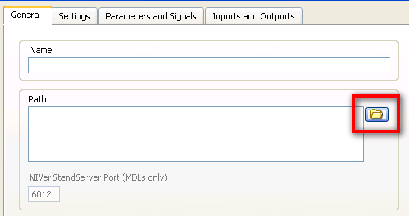

* 1. Browse to **<Public Documents>\National Instruments\NI VeriStand 2014\Projects\Tutorial\Models\Linear Helicopter Model.lvmodel.**
  2. Select **OK.**

Recall that this model was created using the LabVIEW Control Design and Simulation Module, but any supported modeling environment or C code can be used. The model has 2 inputs (left and right motor power) as well as 6 outputs (the pitch, travel, and elevation position and velocity). Using the 2 inputs, the model will produce the appropriate outputs to simulate the response of the system to the embedded controller’s input.

* 1. Select **Simulation Models** from the explorer tree.

1. Select **Add Simulation Model**.
2. Browse to **<Public Documents>\National Instruments\NI VeriStand 2014\Projects\Tutorial\Models\Linear Helicopter Controller.lvmodel.**
3. Select **OK.**

This model was also created using the LabVIEW Control Design and Simulation Module. The model has 8 inputs (the pitch, travel, and elevation position and velocity, and movement set points) as well as 2 outputs (motor power). Using the 2 set point inputs and feedback from the helicopter model, the controller model will produce the appropriate outputs to move the helicopter model to the set point provided.

* 1. Let’s set one model to execute before the other (in series)

1. Select **Execution Order** from the explorer tree.
2. Drag the red color bar corresponding to **Linear Helicopter Model** from **Group 0** to **Group 1**.

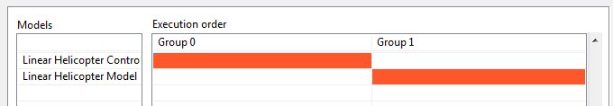

* 1. Now we will map our models input and output together

1. Select **Tools** » **Edit Mappings** from the menu.
2. Select **Simulation Models** » **Models** » **Linear Helicopter Controller** » **Outports** from the sourcewindow, and **Simulation Models** » **Models** » **Linear Helicopter Model** » **Inports** from the destination window.
3. Select the **Connect** button to create the mapping.

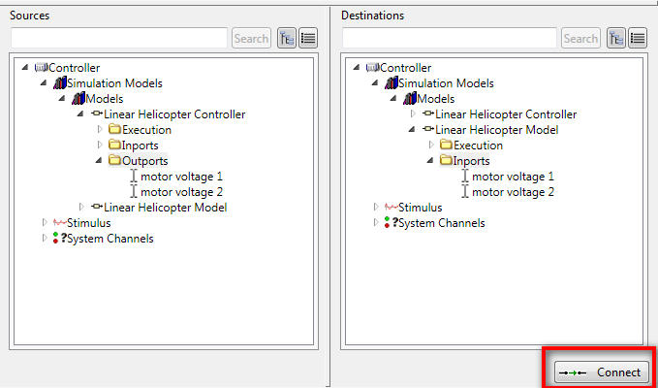



NI VeriStand also provides an import and export mapping tool. This can expedite the creation of large system mappings.

* 1. Select the **Open** icon from System Mapping Toolbar.

1. Browse to **<Public Documents>\National Instruments\NI VeriStand 2014\Projects\Tutorial\helicopter mapping.txt.**
2. Select **Import** to import the rest of the mappings into NI VeriStand.
3. Select **Exit** and you should see additional mappings added to the mappings table.
4. The complete mappings for the HIL system are shown in the table below:

|  |  |
| --- | --- |
| **Source** | **Destination** |
| Linear Helicopter Controller » Outports » motor voltage 1 | Linear Helicopter Model » Inports » motor voltage 1 |
| Linear Helicopter Controller » Outports » motor voltage 2 | Linear Helicopter Model » Inports » motor voltage 2 |
| Linear Helicopter Model » Outports » elevation angle | Linear Helicopter Controller » Inports » elevation angle |
| Linear Helicopter Model » Outports » elevation speed | Linear Helicopter Controller » Inports » elevation speed |
| Linear Helicopter Model » Outports » pitch angle | Linear Helicopter Controller » Inports » pitch angle |
| Linear Helicopter Model » Outports » pitch speed | Linear Helicopter Controller » Inports » pitch speed |
| Linear Helicopter Model » Outports » travel angle | Linear Helicopter Controller » Inports » travel angle |
| Linear Helicopter Model » Outports » travel speed | Linear Helicopter Controller » Inports » travel speed |

* 1. Select **Controller** in the System Explorer tree.
  2. Observe the Execution Settings.
  3. Modify the **Target Rate** to 1000 Hz (1 kHz).

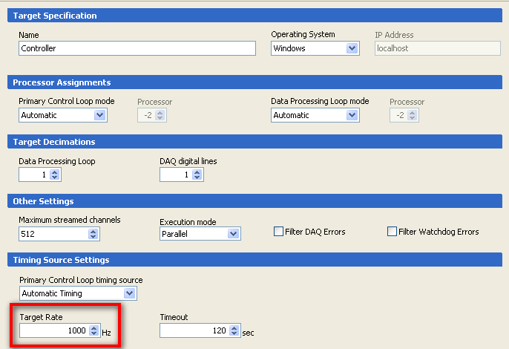

* 1. **Save** and **close** the System Explorer.

Now that we have imported our models and mapped them together, we can run our configuration and have the controller model control the helicopter model. We can define our set points and watch our controller move the helicopter model to that point.

* 1. Select **Operate » Run** to deploy and run your configuration.
  2. Rename this new screen by selecting **Screen » Screen Properties…**
  3. Name the screen **MIL.**
  4. Select **OK.**
  5. Switch to Edit Mode. Select **Screen » Edit Mode** or CTRL+M.
  6. From the Workspace Controls (on the left), click and drag to add a **Graph(Simple)**.

1. Graph Title**:** **Fan Power**
2. Select item:   
   **Controller » Simulation Models » Models » Linear Helicopter Controller » Outports**
3. Select  to add these channels to the graph.
4. Select the **Format & Precision** tab.
5. Change the Y scale **Maximum** and **Minimum** to be 1 and -1 respectively.
   1. From the Workspace Controls, drag and drop to add a **Numeric Control(Slide)**
   * Channel: **Controller » Simulation Models » Models » Linear Helicopter Controller » Inports » Elevation Setpoint**
   * Control Label: **Elev.**
   1. From the Workspace Controls, drag and drop to add a **Numeric Control(Dial)**
   * Channel **: Controller » Simulation Models » Models » Linear Helicopter Controller » Inports » Travel Setpoint**
   * Format & Precision Tab: Scale Min: -**100**

To better visualize the behavior of our model, we will add a custom workspace object created using LabVIEW. This indicator uses the LabVIEW 3D picture control to provide a 3D animation of the system. We will connect the 3D picture control inputs to the outputs of our model that provides the current state (position) of the helicopter model.

* 1. Add a Custom Indicator **Helicopter(3dView)**
  + Elevation: **Controller » Simulation Models » Models » Linear Helicopter Model » Outports » output » Elevation angle (deg)**
  + Pitch: **Controller » Simulation Models » Models » Linear Helicopter Model » Outports » output » Pitch angle (deg)**
  + Travel:  **Controller » Simulation Models » Models » Linear Helicopter Model » Outports » output » Travel angle (deg)**
  1. Disable Edit Mode**.** Select **Screen » Edit Mode** (Ctrl + M).
  2. Change the Elevation and Travel controls and watch the 3D Picture Control Move to the set point and the fan power modulate. You are now telling the controller where to move the model and are performing Model-In-the-Loop testing of the controller.

1. **Build a Simple Real-Time Stimulus Profile**

Now that we have learned how to use the NI VeriStand Workspace to create our UI, the next step is to create and run automated tests to qualify our controller unit. NI VeriStand has many tools including an Alarm Monitor, Channel Fault Manager, TDMS File viewer, and Stimulus Profile Editor. In this phase of the hands-on, we create a Real-Time test profile using the stimulus profile editor. To learn more about the other tools provided by NI VeriStand, see the NI VeriStand documentation or open them and try them out.

Using the NI VeriStand stimulus profile editor, you can create a profile to create sophisticated test sequences that can represent any real-world condition. The Stimulus to profile editor includes looping, branching, composable mathematical functions, and multitasking. You can also use it to replay waveforms, complete a series of steps, perform data logging, or pass/fail analysis. At the end of each profile, the stimulus profile editor will generate a report that summarizes the results of the tests. This exercise walks you through creating a test profile using the Stimulus Profile Editor. Each of the individual sequences that are called from the Stimulus Profile Editor run deterministically (when deployed to a real-time target), but the stimulus profile itself runs on the Windows host.

* 1. If you did not finish the last phase, please open the **Phase I Solution** for this exercise and use it to complete this phase.
     1. Select the **Phase I Solution** project on the left side of the NI VeriStand Getting Started Window.
     2. If **Phase I Solution** is not located here, select the **Browse** folder, open the **<Public Documents>\National Instruments\NI VeriStand 2014\Projects\Tutorial** folder, and select **Phase I Solution.nivsproj**.
     3. Select **Configure Project** to open the Project Explorer.
     4. Select theto deploy and run your configuration.
  2. In the project, right click **Profiles** and select **New » Stimulus Profile File**
     1. Save this into the **<Public Documents>\National Instruments\NI VeriStand 2014\Projects\Tutorial\Stimulus Profiles** folder



This will open the NI VeriStand Stimulus Profile Editor, which is a stand-alone executable that runs independently of NI VeriStand. The NI VeriStand Stimulus Profile Editor is composed of two main components, stimulus profiles and Real-Time Sequences. Stimulus profiles run on the Windows host and act as a test executive for real-time tests. They can call Real-Time Sequences, perform NI VeriStand tasks such as opening and closing of NI VeriStand projects and Workspaces, and perform data logging.

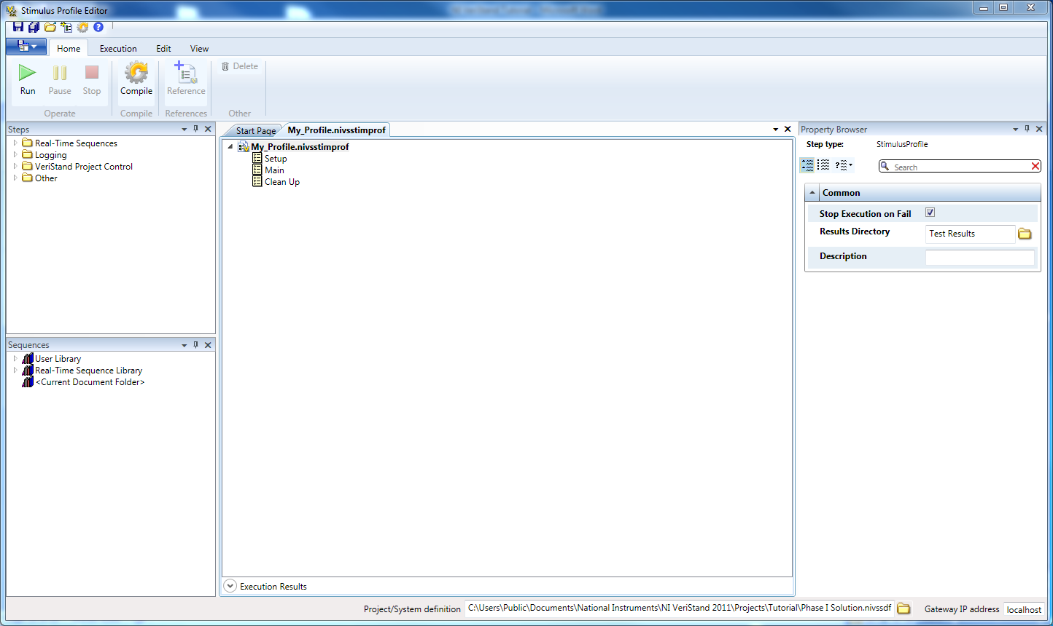

The second component of the stimulus profile editor is the Real-Time Sequence. Real-Time Sequences are deployed to the real-time target and run deterministically to conduct real-time tests. There are many tools available in Real-Time Sequences for generating sophisticated test patterns. Some of these tools include looping, branching, multi-tasking, and composable mathematical functions. You can also use Real-Time Sequences as sub-sequences, so that you can create libraries of Real-Time Sequences to make real-time test sequence creation more efficient.

* 1. We will now create a profile to control the helicopter’s elevation and travel. The first thing that we will need to do is to verify that our stimulus profile is bound to the current System Definition.
     1. Verify that the file path (shown in the image above) is set to **<Public Documents>National Instruments\NI VeriStand 2014\Projects\Tutorial\Phase I Solution.nivsproj**.
     2. All of the channels in this NI VeriStand System Definition will now be available to us in the Stimulus Profile.
  2. First, we will control the Elevation Setpointof our system definition. We will automate the elevation set point to initialize to 0, wait for 5 seconds, rise to 11, wait for 10 seconds, and then rise to 19.

The User Library is a place to store custom real-time sequences, so that they can be used across stimulus profiles. If a real-time sequence is placed in the <Public Documents>\National Instruments\NI VeriStand 2014\Stimulus Profiles\ directory, it will automatically populate in the User Library of the Stimulus Profile Editor. This allows you to create custom libraries of real-time sequences that can be easily reused across real-time testing projects.

* + 1. In the Sequences Palette, expand the **User Library » Tutorial** menus and drag the **Set Single Value** Sequence into the **Setup** section of the stimulus profile.
    2. In the Parameters window, map the **Channel** parameter to the **Elevation Setpoint** channel in the System Definition.
       - Select the Channel radio button associated with **Channel**
       - Select the  and use the search bar to find **Elevation Setpoint**.
       - Select **Elevation Setpoint**

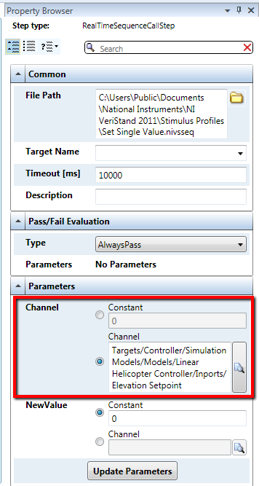

* + 1. In the Sequences Palette, expand the **Real-Time Sequences Library » Standard » Timing** menus and drag the Drag a **Wait** sequence into the **Setup** section of the stimulus profile under the Set Single Value sequence.
       - Set **Duration** to 5.
       - In the **Pass/Fail Evaluation** section, change the Type to **Always Pass**

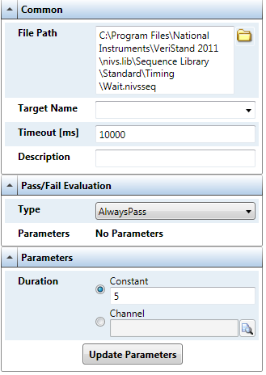

* + 1. In the Sequences Palette, expand the **Real-Time Sequences Library » Standard » Waveforms** and drag a **Ramp** sequence into the **Main** section of the stimulus profile.
       - Set the RampOut Parameter to Elevation Setpoint channel by using the same procedure as in step 4a.
       - Set **Initial Value** to 0
       - Set **Final Value** to 11
       - Set **Duration** to 1
    2. Drag a **Wait** sequence into the **Main** section of the stimulus profile under the Ramp Sequence
       - Set **Duration** to 10
       - In the **Pass/Fail Evaluation** section, change the Type to **Always Pass**
    3. Drag a **Ramp** sequence into the **Clean Up** Section of the stimulus profile
       - Set the RampOut Parameter to **Elevation Setpoint** channel by using the same procedure as in step 4a.
       - Set **Initial Value** to 11
       - Set **Final Value** to 19
       - Set **Duration** to 1
    4. Drag a **Wait** sequence into the **Clean Up** section of the stimulus profile under the Ramp Sequence
       - Set **Duration** to 10
       - In the **Pass/Fail Evaluation** section, change the Type to **Always Pass**

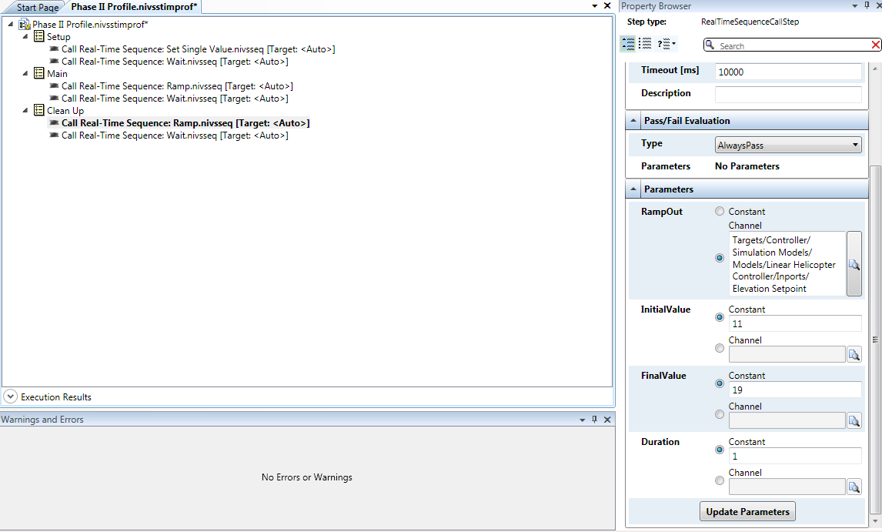



We can have multiple Real-Time Sequences running in parallel. We will run two sets of Real-Time Sequences in parallel to stimulate the controller’s (UUT) elevation and travel set points simultaneously. We can add Real-Time Sequence Groups wherever we need to run two Real-Time Sequences in parallel. Anything under a Real-Time Sequence group will run in parallel.

* 1. We will now add Real-Time Sequences to control Travel Set Point. We will automate the elevation set point to initialize to 0, wait for 5 seconds, ramp to 33, wait for 10 seconds, and ramp to -12.
     1. Drag a **Real-Time Sequence Group** to the top of the **Setup** section of the stimulus profile.
        + Drag the existing **Set Single Value** Sequence into the Real-Time Sequence group so that it becomes a child of the sequence group

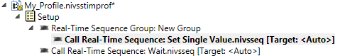

* + 1. Drag a **Set Single Value** sequence into the new Real-Time Sequence group
       - In the Parameters window, map the **Channel** parameter to the **Travel Setpoint** channel in the System Definition.
         * Select the Channel radio button associated with **Channel**
         * Select the  and use the search bar to find **Travel Setpoint**.
         * Select **Travel Setpoint**
    2. Drag a **Real-Time Sequence Group** to the top of the **Main** section of the stimulus profile.
       - Drag the existing Ramp Sequence into the Real-Time Sequence group so that it becomes a child of the sequence group
    3. Drag a **Ramp** sequence into the new Real-Time Sequence Group in the **Main** section of the stimulus profile.
       - Set the RampOut Parameter to **Travel Setpoint** by using the same procedure as in step 5b.
       - Set **Initial Value** to 0
       - Set **Final Value** to 33
       - Set **Duration** to 1
    4. Drag a **Real-Time Sequence Group** to the top of the **Clean Up** section of the stimulus profile.
       - Drag the existing Ramp Sequence into the Real-Time Sequence group so that it becomes a child of the sequence group
    5. Drag a **Ramp** sequence into the new Real-Time Sequence Group in the **Clean Up** section of the stimulus profile.
       - Set the RampOut Parameter to **Travel Setpoint** by using the same procedure as in step 5b.
       - Set **Initial Value** to 33
       - Set **Final Value** to -12
       - Set **Duration** to 1
    6. When complete, the profile should look as seen below:

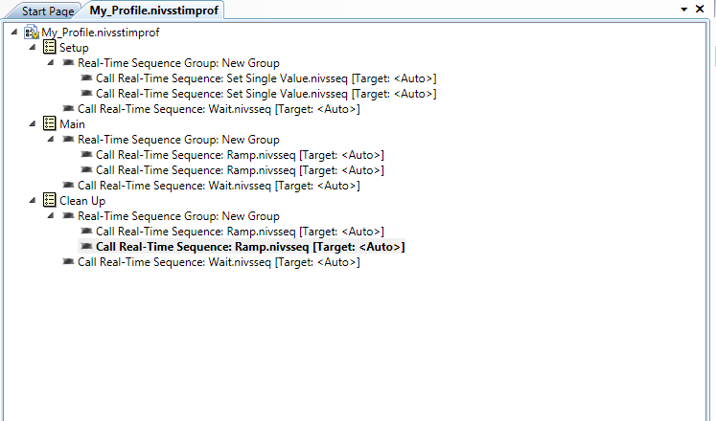

* 1. We will now configure our stimulus profile to log the Travel Setpoint and Travel Angle channels in our system.
     1. Drag a **Start Logging** Step into the **Setup** section of the stimulus profile directly above the **Wait** step.
     2. Select **Channel Group** directly below the Start Logging step.
     3. In the Property Browser, select the  and navigate to **Targets » Controller » Simulation Models » Models » Linear Helicopter Controller » Inports**. Select the **Travel Setpoint** and **Travel Angle(deg)** channels by selecting their respective boxes.
     4. Drag a **Stop Logging** Step to the bottom of the **Clean Up** section of the stimulus profile.
  2. Configure the logging file
     1. The log file will go to the results directory determined by selecting the stimulus profile header (the top of the stimulus profile). By default, this directory will be <Your Stimulus File Path>\Test Results\UUT 1\
     2. Leave this as the file directory.

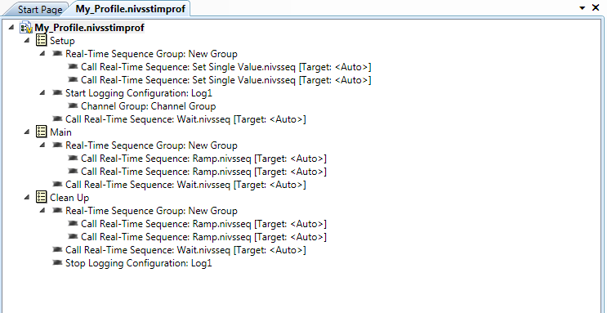



**Note**: You can have multiple files for logging separate groups of signals or trigger off of different conditions. You can also choose different log rates for each file to allow slower changing channels to be logged separately for optimized performance and disk usage.

* 1. Save the stimulus profile by selecting the in the top left corner.
  2. Select the  in the top right corner of the Stimulus Profile Editor menu to shrink the window, so that you can view both the Stimulus Profile Editor and the NI VeriStand Workspace simultaneously.
  3. Select **Run** on the Stimulus Profile Editor to run the profile.
     + Notice that the Stimulus Profile Editor highlights the active sequence, so that you can tell which part of the profile is running.
     + Observe the helicopter actions and fan power graph.

**Note:** There is a report that gets generated once the Stimulus Profile has completed. This report will display in a web browser, and it includes pass/fail analysis, time stamp information, and general test setup information.

* 1. Use the TDMS File Viewer Tool to observe the logged data from the profile when it is finished.
     1. Open the TDMS File Viewer by selecting **Tools » TDMS File Viewer** from the workspace menu.
     2. Select **File » Open**.
     3. Find the log file you created at **<Public Documents>National Instruments\NI VeriStand 2014\Projects\Tutorial\Stimulus Profiles\Test Results\UUT 1\**
     4. Select the top most tree item in the left pane.
     5. Select the **Analog values (graph)** tab.



NI DIAdem or Excel can also be used to examine the data log files. Using NI DIAdem, you can load multiple files simultaneously, perform interactive and automated analysis, and configure re-usable report templates for enhanced test data processing.

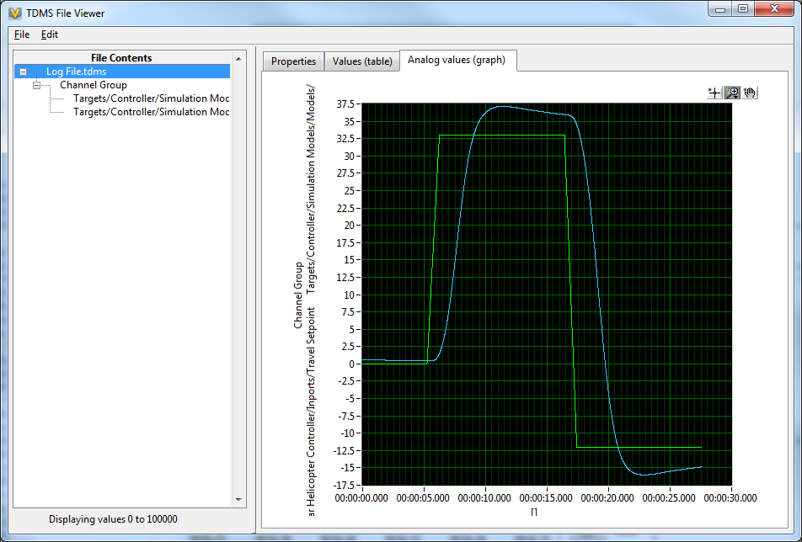

**III. Open & Run Advanced Configuration**

In this phase, we will look at a pre-made solution which illustrates additional functionality of NI VeriStand. This phase is an example of the additional functionality of Real-Time Sequences, alarms, and procedures. Stimulus profiles can call Real-Time Sequences for the portions of the test that needs to run deterministically. Some or your entire test could be contained in a Real-Time Sequence. This example demonstrates a complete real-time test contained within a Real-Time Sequence and called by a Stimulus Profile.

1. Close the NI VeriStand workspace and project.
2. From the Getting Started Window select the **Phase III Solution**.
3. If **Phase III Solution** is not located here, select the **Browse** folder, open the **<Public Documents>\National Instruments\NI VeriStand 2014\Projects\Tutorial** folder, and select **Phase III Solution.nivsproj**.
4. Select **Configure Project** to open the project.
5. Open and navigate through the System Explorer to view the additional functionality:
   1. Expand the **System Definition File** section.
   2. Right click the **Phase III Solution.nivssdf** file and select **Launch System Explorer.**
   3. Expand **User Channels**, **Procedures,** and **Alarms** to see the new additions to the configuration.
      * The Alarm, “Reset has been pressed”, is used to monitor the UserChannel, “Reset MIL.” When this User Channel has exceeded the alarm limits, the alarm triggers and calls the “Reset MIL” Procedure.
6. **Close** the System Explorer.
7. Select **Operate » Run** to deploy the Phase III solution configuration and open the workspace.
8. Open the pre-made Phase III Solution.nivsstimprof stimulus profile.
   1. Expand the **Profiles** section of the project explorer.
   2. Double click **Phase III Profile.nivsstimprof.**
9. The Stimulus Profile Editor will open and allow you to view the stimulus profile.

* This stimulus profile resets the model and helicopter, and then calls a Real-Time Sequence to send the helicopter to four different travel and elevation set point pairs.

1. In the Sequences Palette, expand the **<Current Document Folder>** menu and double click **CheckElevationAndTravel.nivsseq** to open and view its functionality.
   * Set point groups are used to organize the sequence
   * Inside each set point group, the Real-Time Sequence sets setpoint channel values and waits until the helicopter is within specific tolerances of the desired value. Once the helicopter is within these tolerances for 3 seconds (or a 30 second timeout), the profile moves on to the next set point pair.
   * Each group also keeps track of pass fail status and the Real-Time Sequence returns the final pass/fail status at the end
2. Select the  in the top right corner of the Stimulus Profile Editor menu to shrink the window, so that you can view both the Stimulus Profile Editor and the NI VeriStand Workspace simultaneously.
3. Select **Run**.

1. **Convert from an MIL to an HIL Test System**

In this exercise we will modify the configuration created in Phase I and Phase II to perform Hardware-In-the-Loop (HIL) testing instead of MIL testing. We will add hardware I/O to the configuration, and remove the controller model. If you do not have hardware, you can follow all of the steps here, but you will be unable to deploy.

Testing systems that include closed-loop control can be challenging because safety, cost, and system availability can make it impractical to perform all of the necessary testing using the complete system. For example, you would not want to make your first test of the embedded control system by performing a test flight because of the consequences associated with finding an error during the test. A technique to address these challenges is HIL simulation. HIL simulation provides a virtual reality for the embedded control unit being tested by simulating the sensor/actuator interactions within the system allowing you, the test engineer, to apply test vectors and observe the system response safely and efficiently.

In order to properly create the HIL system, the embedded control unit will communicate with a model running on a National Instruments PXI embedded Real-Time controller with actual physical hardware signals just like it would with a real helicopter. To accomplish this task, your NI VeriStand configuration will utilize an FPGA based IO card loaded with a LabVIEW FPGA personality designed for this application.

1. Open your completed Phase II project. If you did not finish Phase II, please open the **Phase II Solution** for this exercise and use it to complete this phase.
2. Select the **Phase II Solution** project file on the left side of the NI VeriStand Getting Started Window.
3. If **Phase II Solution** is not located here, select the **Browse** folder, open the **<Public Documents>\National Instruments\NI VeriStand 2014\Projects\Tutorial** folder, and select **Phase II Solution.nivsproj**.
4. Using the cable provided, connect **Port 1 of the R-series FPGA IO card to the sbRIO embedded controller (UUT)**.
5. Add an FPGA Target
   * 1. Expand the System Explorer tree to **Controller » Hardware » Chassis » FPGA.**
     2. Select **FPGA** and then select **Add FPGA Target.**

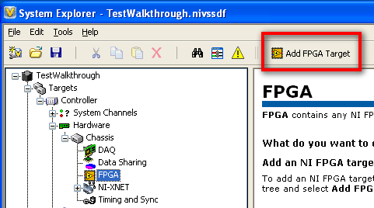

* + 1. Browse to **<Public Documents>\National Instruments\NI VeriStand 2014\Projects\Tutorial\FPGA Personalities** and select the fpgaconfig file that matches the model number of your R series DAQ card.
* **Note**: You will either have a PXI-7811, PXI-7831, PXI-7833, or a PXI-7854 in your chassis. Select the corresponding file to your hardware.

|  |
| --- |
|  |

This FPGA target personality was created using the shipping NI VeriStand LabVIEW FPGA template. This template increases development productivity by minimizing programming architecture and focuses on the creation of the necessary I/O personality. The in ports and out ports seen in the system explorer are defined by an XML file (.fpgaconfig) that describes how the FPGA code interfaces to the NI VeriStand Engine.

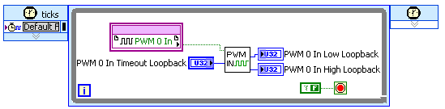  
FPGA PWM Input Code

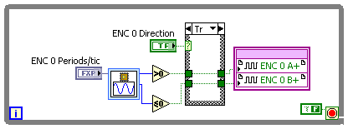  
FPGA Encoder Output Code

NI VeriStand provides built in personalities for many common FPGA I/O types, Analog Input, Analog Output, Digital I/O, Pulse Trains, Pulse Width Modulation, and more. Note that In addition to user-defined FPGA personalities, Multifunction Data Acquisition, LIN, CAN, FlexRay, Timing and Sync hardware, and more can be configured directly in NI VeriStand.

1. Remove the controller model from the configuration. Right click **Simulation Models »** **Models »** **Linear Helicopter Controller** and select delete. Select **OK** on the warning dialog.

* Now we will map our system physical inputs and outputs to those of the helicopter model.

1. Select **Tools** » **Edit Mappings**.
2. Select each of the two invalid mappings at the bottom of the window and select **disconnect**.
3. Select **Hardware** » **Chassis** » **FPGA** » **RIO0** » **Input** » **Fan Power** » **Left Fan Power** from the sourcewindow, and **Simulation Models** » **Models** » **Linear Helicopter Model** » **Inports**  » **motor voltage 1** from the destination window.
4. Select the **Connect** button to create the mapping.

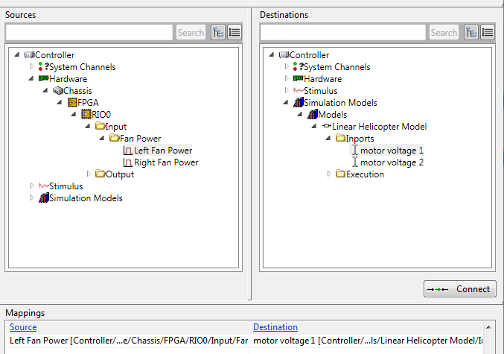



We will again use the mapping import tool to expedite the creation of the system mappings.

1. Select the **Open** icon from System Mapping Toolbar.
2. Browse to **<Public Documents>\National Instruments\NI VeriStand 2014\Projects\Tutorial\FPGA mapping.txt.**
3. Select **Import** to import the rest of the mappings into NI VeriStand.
4. Select **Exit** and you should see 4 additional mappings added to the mappings table.
5. The complete mappings for the HIL system are shown in the table below:

|  |  |
| --- | --- |
| **Source** | **Destination** |
| Left Fan Power | Motor Voltage 1 |
| Right Fan Power | Motor Voltage 2 |
| Elevation speed (deg/sec) | Elevation Velocity |
| Pitch speed (deg/sec) | Pitch Velocity |
| Travel speed (deg/sec) | Travel Velocity |

1. We also need to create a procedure to reset our UUT so we can start from a known state.
2. Select **Procedures.**
3. Select **Add Procedure.**
4. Name the procedure **Reset HIL.**
5. Create a procedure step by selecting **Add** then **Set Multiple Variables.**
6. Double click the newly added step and configurewith these parameters:
   * Name**:**  **Stop Model & Controller**
   * Numberof Channels to Set**:** **2**
   * Channel 1**:** **Controller » Simulation Models » Linear Helicopter Model » Execution » Model Command**
   * Value 1: **2**
   * Channel 2: **Controller » Hardware » Chassis » FPGA » RIO0 » Output » Digital » Controller Reset**
   * Value 2: **1**
7. From the Reset HIL page, select **Add** then **Dwell.**
   * **Constant Value: 0.1**
8. Select **OK.**
9. Continue adding steps, using set variable and dwell to match the following:  
     
   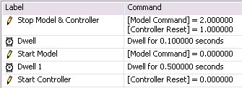
10. Back in procedures**,** let’s make our HIL Reset trigger on start up of the NI VeriStand engine.
11. Select **Procedures** from the left pane of the system explorer window.
12. Check **On start execute procedure** at the bottom of the Procedure window.
13. Select **Reset HIL** from the drop down menu.

Now that we have removed our controller model and mapped our plant model to physical I/O, we have converted our MIL system to an HIL system. We can deploy our configuration and have the controller hardware (the device we’re testing) control the model of the linear helicopter. We can use the same stimulus profiles created for MIL testing for HIL testing.

* **NOTE:** this section only applies if you are using Real-Time (RT) hardware.

1. Launch Measurement and Automation Explorer by navigating to **Start » All Programs » National Instruments » Measurement and Automation Explorer**.
2. Select the PXI RT target that is listed under **Remote Systems**.
3. Note the **IP address**.
4. Back in the NI VeriStand System Explorer, select **Controller.**
5. Change **Operating System** to PharLap.
6. Enter the **IP Address** you noted in MAX.
7. **Save** and **close** the System Explorer.
8. Select **Operate » Run** to deploy and run your configuration.

The behavior of the system should be identical as the MIL testing, and the *same stimulus profiles* can be used to validate the hardware controller.

1. **Configure Logging and Analyze Data in DIAdem**

We have learned how to configure and execute stimulus profiles, which include signal generation, test automation, and data logging. Now we will learn how to configure data logging directly from the Workspace, and we will see how NI VeriStand can be used with NI DIAdem to perform post processing of data and generate reports. Using NI VeriStand and DIAdem together enables you to automate data analysis and report generation, so that every test produces consistent data that can be easily compared to previous test results.

1. Open DIAdem and open NI VeriStand if it is not already open.
2. In NI VeriStand, open your completed Phase II project. If you did not finish Phase II, please open the **Phase II Solution** for this exercise and use it to complete this phase.
   1. Select the **Phase II Solution** project file on the left side of the NI VeriStand Getting Started Window.
   2. If **Phase II Solution** is not located here, select the **Browse** folder, open the **<Public Documents>\National Instruments\NI VeriStand 2014\Projects\Tutorial** folder, and select **Phase II Solution.nivsproj**.
3. Select **Configure Project** to open the Project Explorer.
4. Select the  to deploy and run your configuration.
5. Enable Edit Mode**.** Select **Screen » Edit Mode** (Ctrl + M).
6. From the Workspace Controls (on the left), click and drag to add a Logging Control.
7. Disable edit mode. Select **Screen » Edit Mode** (Ctrl + M).

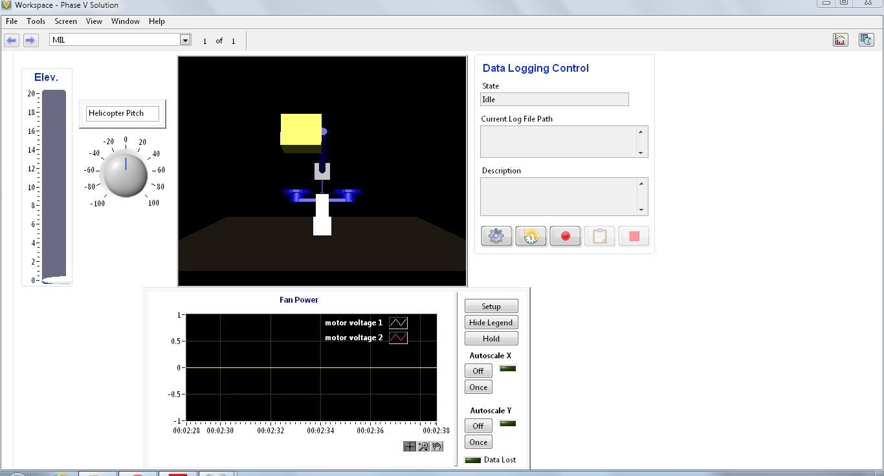

1. Select the  on the data logging control to open the data logging configuration window.

The data logging configuration window allows you to set many different data logging options. While this tutorial will walk through some of the options, please look through all of the different menus to see all of the different settings that can be configured. For a demonstration about how to use this data logging control, watch the video at [Combining NI VeriStand Software and NI DIAdem Software to Improve Real-Time Test Data Management](http://www.ni.com/white-paper/14830/en/).

1. Select the **Channels Menu** 
   1. Select **Add Channels**
   2. Navigate to Simulation Models » Linear Helicopter Model » Inports and expand the inports menu. Select **motor voltage 1** and **motor voltage 2**.
   3. Select **OK**
2. Select **Start Trigger**.

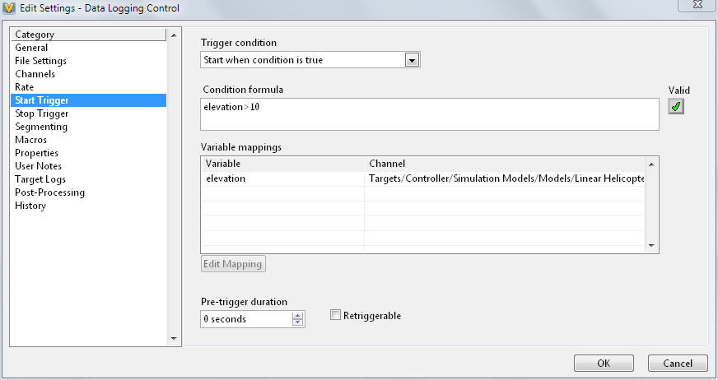

* 1. Under Trigger condition, select the drop down arrow and select **Start when condition is true**.
  2. Select the box labeled **Condition formula**.
  3. Type **elevation>10** in the box.
  4. Select the box labeled **Variable mappings**. Notice that the elevation variable appears.
  5. Select the **elevation variable**
  6. Select **Edit mapping**.
  7. In the Channel selection box, search for **Elevation Setpoint** and select it.
  8. Select **OK**.

1. Select **Stop Trigger**.
   1. Under Trigger condition, select the drop down arrow and select **Start when condition is true**.
   2. Select the box labeled **Condition formula**.
   3. Type **elevation<10** in the box.
   4. Select the box labeled **Variable mappings**. Notice that the elevation variable appears.
   5. Select the **elevation variable**
   6. Select **Edit mapping**.
   7. In the Channel selection box, search for **Elevation Setpoint** and select it.
   8. Select **OK**.
2. Select **Macros**.

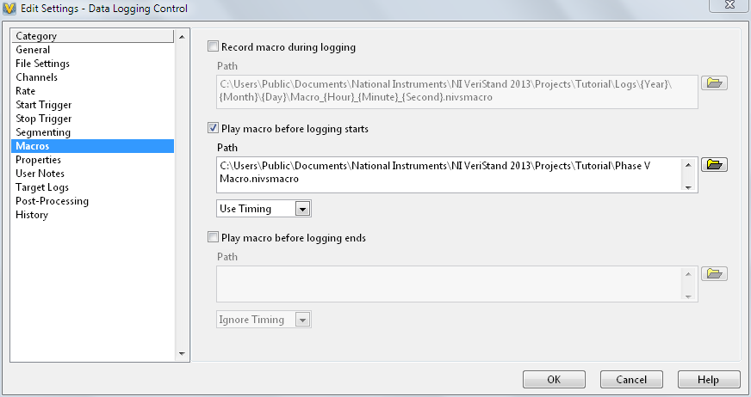

* 1. Check the box that says **Play macro before logging starts**.
  2. Browse to the **<Public Documents>\National Instruments\NI VeriStand 2014\Projects\Tutorial** and select the **Phase V Macro.nivsmacro**.
  3. Select **OK**
  4. In the drop down below the file path, select the drop down arrow and then select **Use Timing**.

1. Select **Properties**
   1. Select the check box that says **Prompt user to enter log file properties when starting a log**.
   2. Select **Add**
   3. In the New Property Window, type **Operator** in the **Property Name** box.
2. Select **Post-Processing**
   1. Select the drop down arrow below *Action to take at the end of log session* and select **Load File in DIAdem**.
   2. Check the box that says Run script.
   3. Browse to **<Public Documents>\National Instruments\NI VeriStand 2014\Projects\Tutorial\DIAdem Files** and select **Phase V.vbs**.
   4. Select the drop down arrow below *Report generation options* and select **Generate PDF report**.
   5. Browse to **<Public Documents>\National Instruments\NI VeriStand 2014\Projects\Tutorial\DIAdem Files** and select **Phase V.tdr**.
3. Select **OK**
4. Select the  button
5. In the Log Properties dialog box, type your name underneath value.
   1. Select **OK** to close the window.

**Note:** The macro will now begin to run, and the log control will wait for a trigger condition. Remember that your trigger condition is to begin logging when the elevation setpoint is greater than 10.

1. Raise the value of the **elevation setpoint** above 10.
   1. If the macro has finished, you will begin to log data. If the macro is still running, hold the elevation setpoint above 10 until after the macro has finished and observe that data logging has begun.
2. Let NI VeriStand log data for a few seconds and then lower the value of **the elevation setpoin**t below 10. Data logging will finish and DIAdem will pop up showing a report.
3. Go back to NI VeriStand and observe the File History window.
4. Double click on the bottom file in the Reports folder. This will open up the PDF report that was created from your data log.

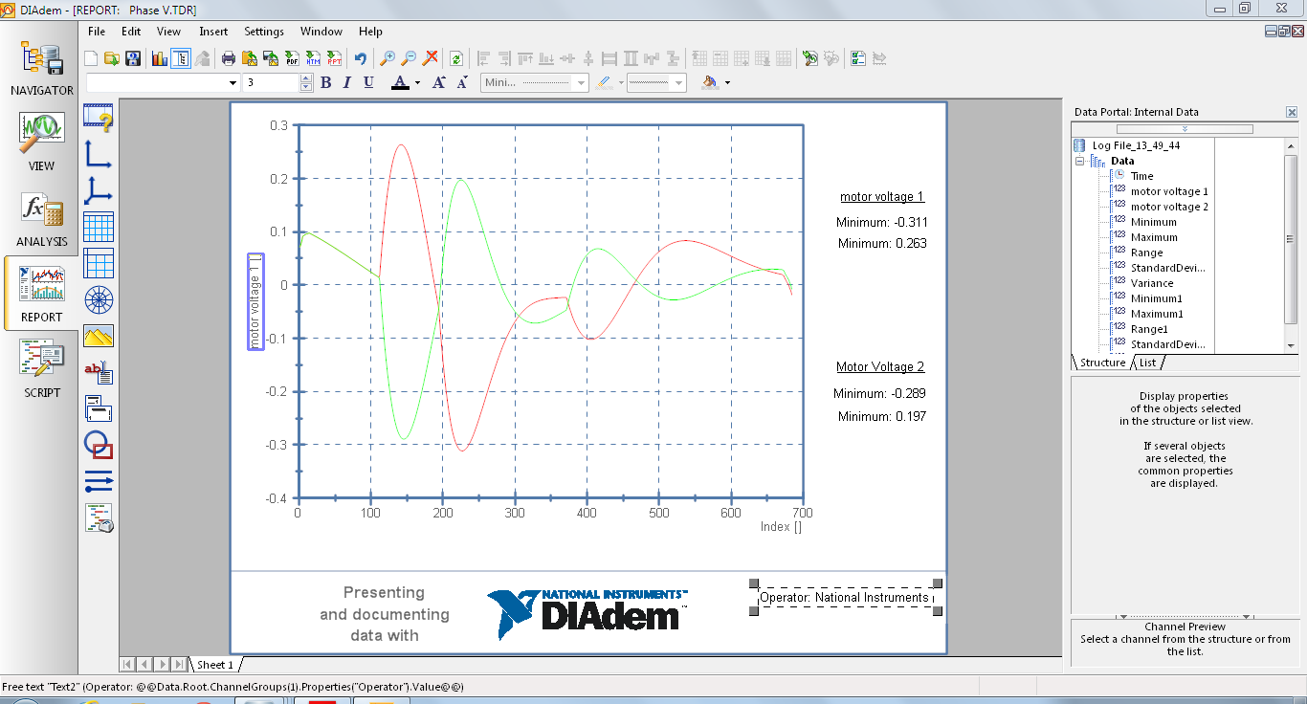

**Summary**

This hands-on exercise demonstrated some features and capabilities of NI VeriStand. If you would like to learn more about NI VeriStand, please visit ni.com/VeriStand for demonstration videos, whitepapers, tutorials, and add-ons to provide additional functionality for your NI VeriStand applications. Here you can download a fully featured evaluation version of NI VeriStand that you can use free for 30 days. For more information about how NI VeriStand can help you create your real-time testing applications more efficiently, request a free on-site consultation from your local NI Field Engineer.